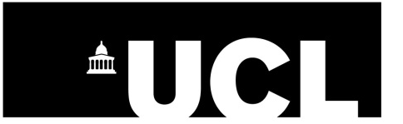
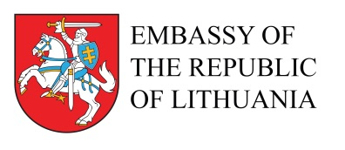

6th LITVAK DAYS IN LONDON

30 November - 1 December, 2016

Jewish Languages in the Lithuanian Context

Wednesday, 30 November
Concert
Venue: Haldane Room, UCL, Wilkins Building, Gower Street, London WC1E 6BT

18:30
Vin d’Honneur
Welcoming remarks

Professor Sonu Shamdasani, Vice-Dean International for Arts and Humanities, UCL
Jonathan Arkush, President of the Board of Deputies of British Jews
Faina Kukliansky, President of the Lithuanian Jewish Community

Introducing concert
Lily Kahn, UCL
Concert performed by Polina Shepherd, performer and composer of Jewish traditional songs with a sprinkling of dance rhythms and modern interpretations to old and new Jewish classic lyrics.

The organisers wish to thank the Embassy of the Republic of Lithuania, the Institute for Polish Jewish Studies, and the Department of Hebrew and Jewish Studies, UCL, for their support of this event

Thursday, 1 December
Conference “Jewish Languages in Lithuanian Context”
Venue: Embassy of Lithuania, Lithuanian House, 2 Bessborough Gardens, London SW1V 2JE

10:00
Welcoming remarks

Asta Skaisgirytė, Ambassador of Lithuania
François Guesnet, University College London

10:15-13:15
Morning Session
Chair: Antony Polonsky, Professor Emeritus of Brandeis University

Anna Verschik, Tallinn University: “Old and New Lithuanian-Yiddish Language Contacts”
Lily Kahn, University College London: “The First Hebrew Shakespeare Translations”
Sima Beeri, London: “From Vilna to Tel-Aviv: Language and Identity in Jewish Palestine”
Mindaugas Kvietkauskas, Institute of Lithuanian Literature and Folklor: “The Encounters with the Cultural Other in the Early 20th Century Jewish Literature of Lithuania”

13:15 -14:15
Lunch break (lunch not provided)

14:15-17:15
Afternoon Session
Chair: Helen Beer, University College London

Natan Cohen, Bar Ilan University: “Yiddish as a Means of Learning Foreign Languages”
Heather Valencia, Emerita, Stirling University: “‘Mayn heymshtot in der lite’: Avrom Sutskever's Lithuanian Heritage”
Marie-Luise Schmidt, University of Potsdam: “Dovid Aynhorn and the Curse of the Metropolis”
François Guesnet, University College London: “Religion, Politics, and Hebrew: The Litvak Beginnings of the Zionist Movement”

Concluding discussion

